Procedure: [Internal Auditing Proc. Title]
- SUMMARY
  - This procedure defines the process and methods for conducting internal quality management system (QMS) audits.
  - The [who?] is responsible for implementation and management of this procedure.
- REVISION AND APPROVAL
Rev. | Date | Nature of Changes | Approved By
[Rev Number] | [Date of Issue] | Original issue. | [Procedure Approver Name]

- TERMS AND DEFINITIONS
  - Audit – systematic and formal comparison of documentation and practice against requirements, performed for the purpose of finding areas of nonconformity or opportunities for improvement.
  - Evidence – data or examples which can be proven true and verified for the purposes of proving an audit finding.
  - Finding – any summary of audit evidence; findings may be positive (reports of compliance) or negative (reports of nonconformity)
  - Major Nonconformity – a nonconformity that shows an [Standard] clause or other requirement has not been implemented at all, or has been implemented in such a way that the requirements are not met at all. Alternatively, a cluster of minor nonconformities which, after review, are found to relate to a single clause or requirement.
  - Minor Nonconformity – a single instance, or small set of single instances, that show a requirement has not been met. At the Lead Auditor’s discretion, a large number of related Minor Nonconformities may instead be filed as a single Major Nonconformity.
  - Nonconformity – any instance where practice or evidence does not comply with requirements.
  - Objective Evidence: information, which can be proven true, based on facts obtained through observation, measurement, test or other means. [Source: ISO 8402]
  - PEAR – Process Effectiveness Assessment Report (see text for discussion)
- CONDUCTING INTERNAL QMS AUDITS
  - Internal quality audits are conducted to ensure ongoing compliance with requirements of the QMS standards, company’s policies and procedures. This is accomplished by auditing against all important processes and areas, and by applying all applicable sections of the standard. Audit requirements include those of [Standard] and any other applicable management system standards, the company’s quality system documentation, as well as requirements of customers or regulatory authorities, as applicable.
  - Audits are conducted by process, and each process must be audited at least once annually.
  - The applicable [Standard] clauses pertaining to each process are defined in Table 1 below. These are the minimum clauses which must be audited for each process; an auditor may audit any clause of the applicable standard, and writing findings against them, depending on how the audit unfolds. (You will have to create this table yourself; see the sample table included with the kit documentation. If this is included in your [Quality Manual Doc Title], revise this paragraph to say so, and remove Table 1 below.)
  - Additional processes of other activities or facilities, outside of the process model, may also be scheduled. For example, this may include safety audits, configuration management audits, etc. In such cases, unique audit forms may be developed for such non-process related audits.
  - The [who?] plans audits according to need, management decision, or customer requirements, and assigns a Lead Auditor for each, as well as any supporting auditor team members. Scheduling is recorded in the Internal Audit Schedule portion of the Internal Audit Log.
  - Auditors are independent of the area being audited.
  - Auditor shall be qualified per section 5 below.
  - Using the Internal Audit Report as a basic checklist, the Lead Auditor will plan the scheduled audit with the appropriate departments and with any other audit team members. The audit team will determine additional checklist items or requirements to verify, and add these to the checklist portion of the Internal Audit Report.
  - Auditors will then conduct the audit by following the steps defined on the Internal Audit Report. These are:
    - Step One: Audit Planning – definition of the scope of the audit, dates of audit, auditors, applicable clauses of affected standards, and QMS documents to review.
    - Step Two: Compare Documentation vs. [Standard]– the auditors will read the applicable [Standard] clauses listed in Step One, as well as the applicable QMS documents; they will note any significant discrepancies, as well as suggestions for improving the documentation. If documents are found not to be properly controlled, this will also be noted.
    - Step Three: Compare Actual Practice vs. Requirements – the auditors will compare actual practice vs. the requirements of both the company QMS documentation and [Standard]. This is done by interviewing employees, examining physical evidence, examining records, and witnessing employees performing work. Evidence of compliance or noncompliance is recorded; at times a single example of evidence may be sufficient to answer multiple questions. The questions in this section are based on Q001 requirements but, customized for [Short Client Name] and its appropriate methods or procedures.
    - Step Four: Review Issues from Previous Audits – the auditors will retrieve the last internal audit for this process and review any open issues, [CAR Form Name]s filed, or auditor notes, and indicate if the issues or concerns were satisfactorily closed, if they are actively being worked, or if they were not properly addressed.
    - Step Five: Verify Overall Effectiveness of the Process – the auditors will answer four generic questions related to the overall effectiveness of the process. This includes writing any findings not otherwise addressed elsewhere in the report or related to clauses of [Standard] that were not called out specifically elsewhere. This also includes documenting strengths and positive observations of the process.
    - Step Six: PEAR (Process Effectiveness Assessment Report) – the Lead Auditor will assign a PEAR rating, based on the PEAR table guidance provided on the report form. If the audit is not for a top-level QMS process, this step may be skipped. See PEAR scoring instructions in section 6 below.
    - Step Seven: Summarize Findings for [CAR Form Abbreviation] System – the audit nonconformities must be fully defined as they are intended to appear in the resulting corrective action requests.
    - Step Eight: Review Audit Report and Submit – the Lead Auditor will finalize the report for submission to management. Where audits involved a team of different auditors, the Lead Auditor will collate all the reports and evidence into a single, final audit report.
  - Auditing shall be performed by obtaining objective evidence to support each requirement, or indicate where nonconformances are found. All findings are recorded on the Internal Audit Report. The internal auditor submits [CAR Form Name]s as necessary to address the nonconformances recorded on the report.
  - When recording nonconformities, each negative finding must include three elements:
    - Indication of the Requirement – the document or clause of the applicable standard which is thought to have been violated.
    - Objective Evidence – traceable indication of the evidence found which supports the claim of a nonconformity (e.g.: documents, products examined, interview results). In all cases, objective evidence must be recorded in sufficient detail to ensure a third party can find the exact evidence at a later date.
    - Details of the Disconnect – a brief statement on why the objective evidence shows a nonconformity against the requirement.
  - Findings shall be rated by Type, whether Corrective, Preventive or Opportunity for Improvement (OFI) for when [CAR Form Name]s are filed.
  - Once [CAR Form Name]s are filed, the responsible managers or parties shall ensure timely corrective action is taken to remedy any nonconformances found. During the [CAR Form Name] effectiveness review, the results of actions taken to address audit findings are evaluated.
  - The [who?] shall update the audit schedule within the Internal Audit Log to reflect to closure of the audit, and enter a summary of audit findings. Based on the results of the audits, and previous audits, the [who?] will then schedule the next audit of the particular process. Processes for which internal audits discover a high number of findings, or critical findings of any number, should be audited more frequently until the process is proven effective again.
  - The completed Internal Audit Report is then published on the company’s server and/or sent to the appropriate managers of the areas audited, in order to report the findings and results. In this way, and in conjunction with the submission of [CAR Form Name]s, all necessary managers are notified of the audit results and may make informed decisions for their departments based on those results.
  - The results of internal audits are also gathered and summarized on the charts generated by the Internal Audit Log, for review by top management during management review and by all employees, through a general posting of the chart.
  - In all cases, auditees are expected to cooperate fully with the audit team.
- INTERNAL AUDITOR QUALIFICATIONS
  - Internal Staff
    - Staff selected as internal auditors will have attended at a minimum a 4-hour [ adjust as you see fit] internal auditor training program and at least 8 hours [ adjust as you see fit] of shadow auditing with a previously qualified internal auditor, or third party auditor.
  - Contract Internal Auditors
    - [Short Client Name] may use approved third-party contract auditors for its internal audit program.
    - Such contractors are not required to have the training requirements indicated for staff above, but must have demonstrated ability to conduct Q001 or related audits; the specific requirements for third party auditors are defined in the procedure [Outsourced Processes Title].
    - Such providers shall also be evaluated and approved per the procedure [Purchasing Proc. Title].
- PEAR SCORING
  - The PEAR score is determined by way of a 3 x 3 matrix, as shown:
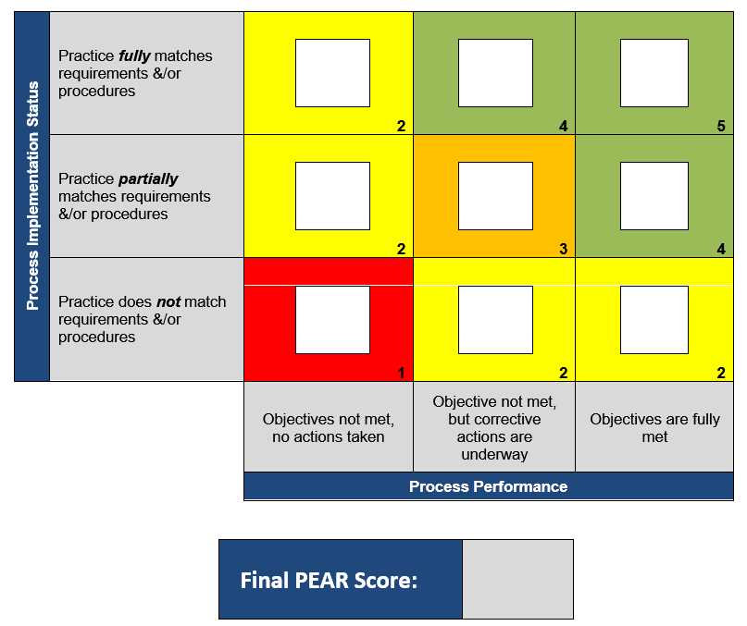

  - First, the auditor will use the vertical column labeled “Process Implementation Status” by determining whether – based on all the other audit results and findings – the practice by employees matches the procedures.
  - Then, the auditor will use the horizontal row labeled “Process Performance” to determine whether the process is meeting its objectives This is done by reviewing the last known process objectives data and goals, typically published in the minutes of Management Review.
  - From these two answers, the appropriate cross-reference is made in the 3 x 3 matrix. The auditor will place an X in the appropriate box. Only one entry must be made.
  - In the bottom right corner of the box is the score for that box. That represents the final PEAR score.
  - The auditor will then enter the PEAR score where indicated at the bottom.
  - For PEAR scores of 1 or 2, an additional audit [CAR Form Abbreviation] must be filed against the process for overall poor process performance.
  - For a PEAR score of 3, an additional audit [CAR Form Abbreviation] is recommended to be filed against the process for overall poor process performance.

